***Registration and reservation manual for booking***

**Registration**

1. Open link https://www.booking.com/
2. In the opened window top right push the button “register”

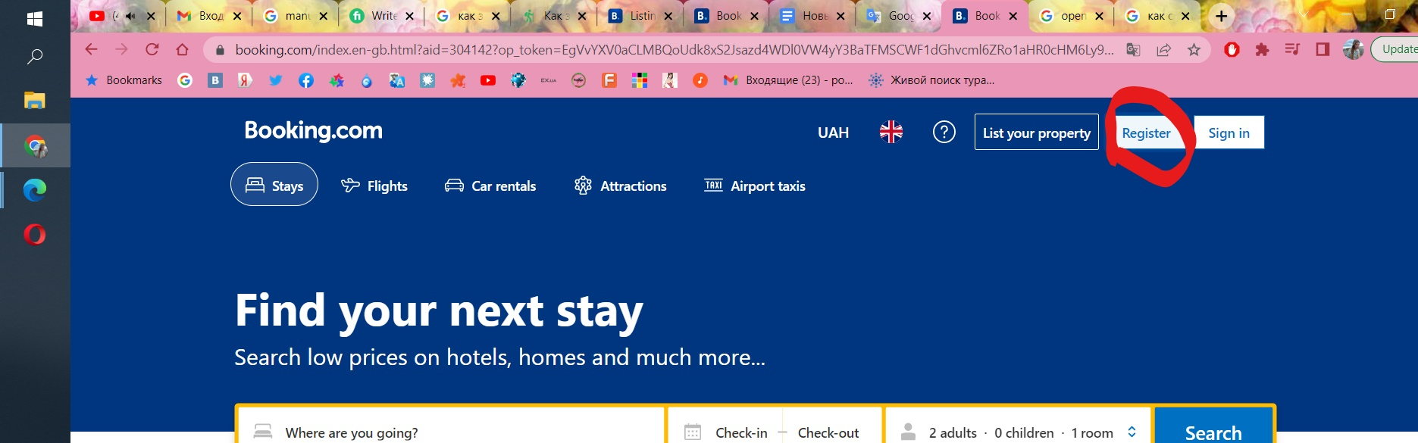

1. In opening window enter your email which you will use for booking or use one of registration options with your account on facebook/google/phone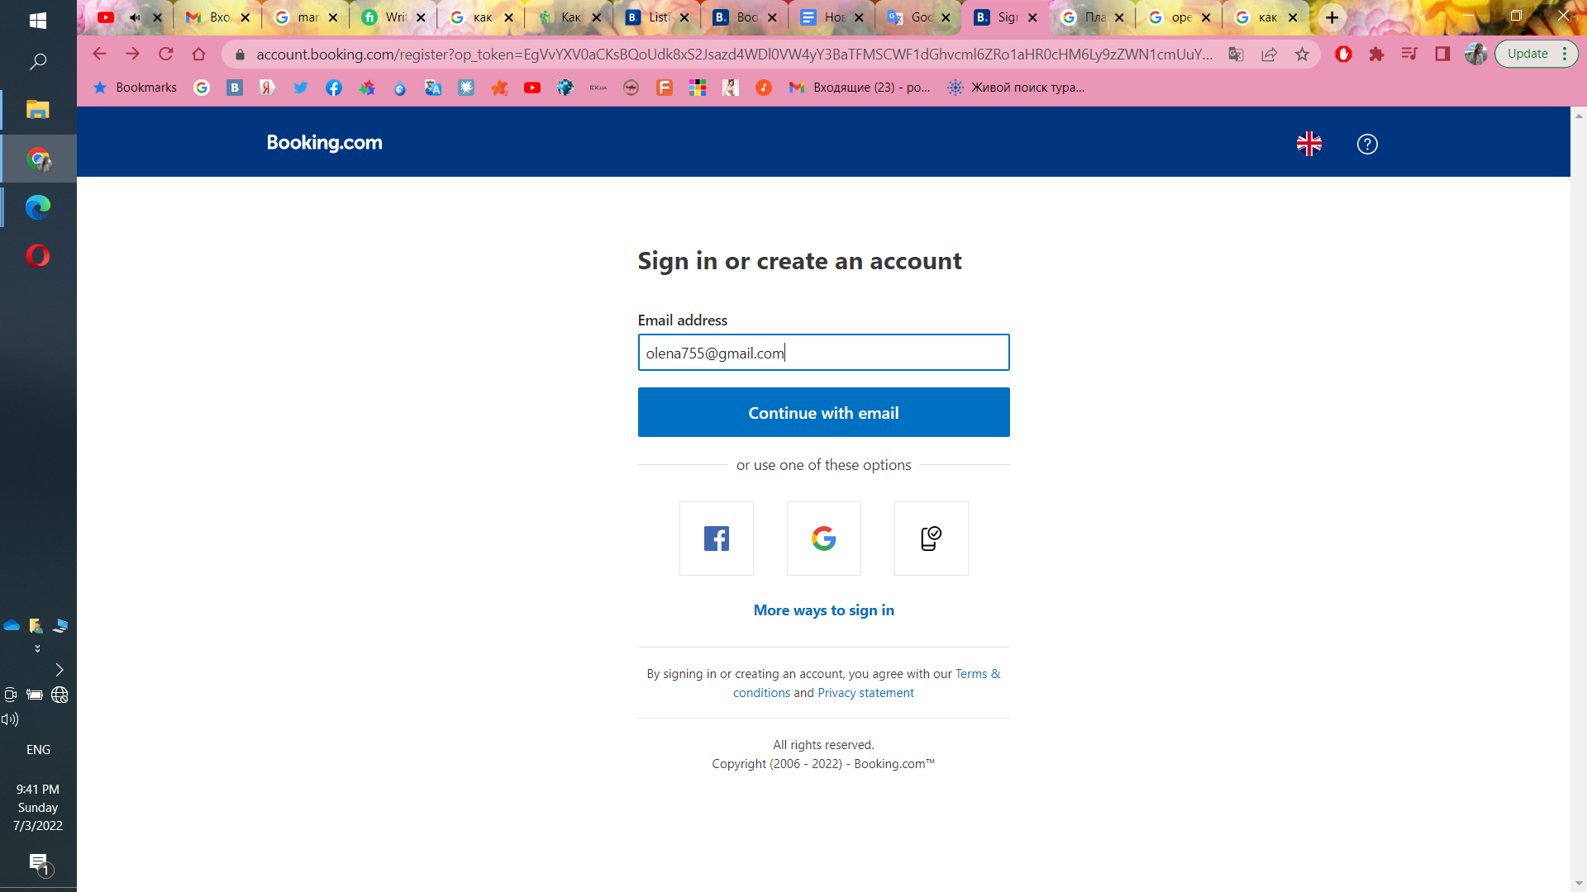
2. If you use registration with email push “Continue with email”

# In opening window create a password use a minimum of 10 characters, including uppercase letters, lowercase letters and numbers and confirm password

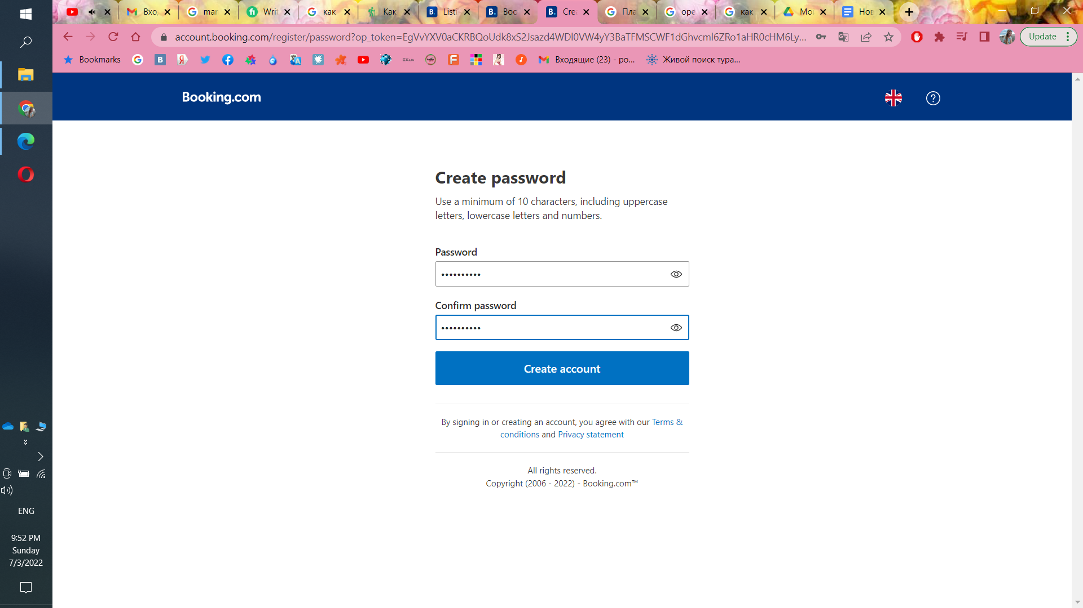

1. Push “create account”
2. To manage your account setting push top right “your account”-manage account

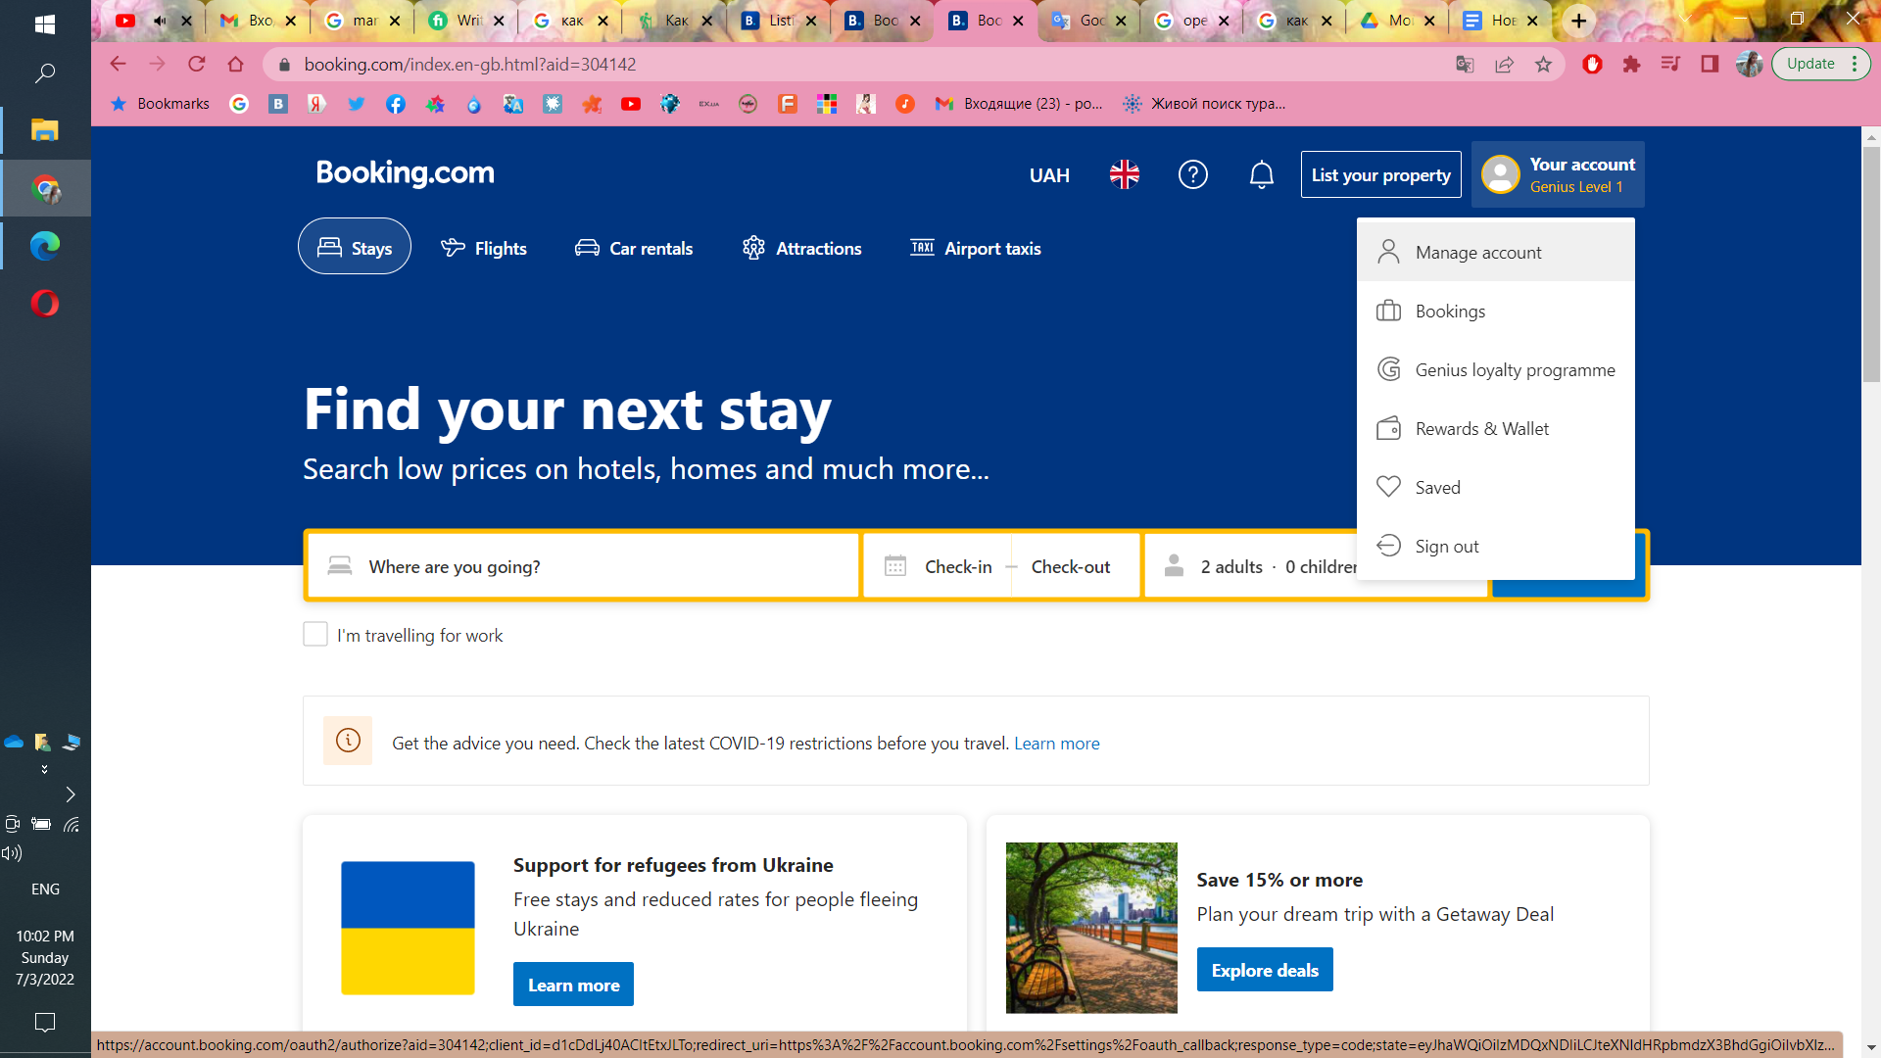

**Reservation**

1. In the first line of the search, you need to enter the destination: the name of the hotel, country, island, city, resort, etc. Here you also need to select the dates for which the trip is planned and the number of expected guests

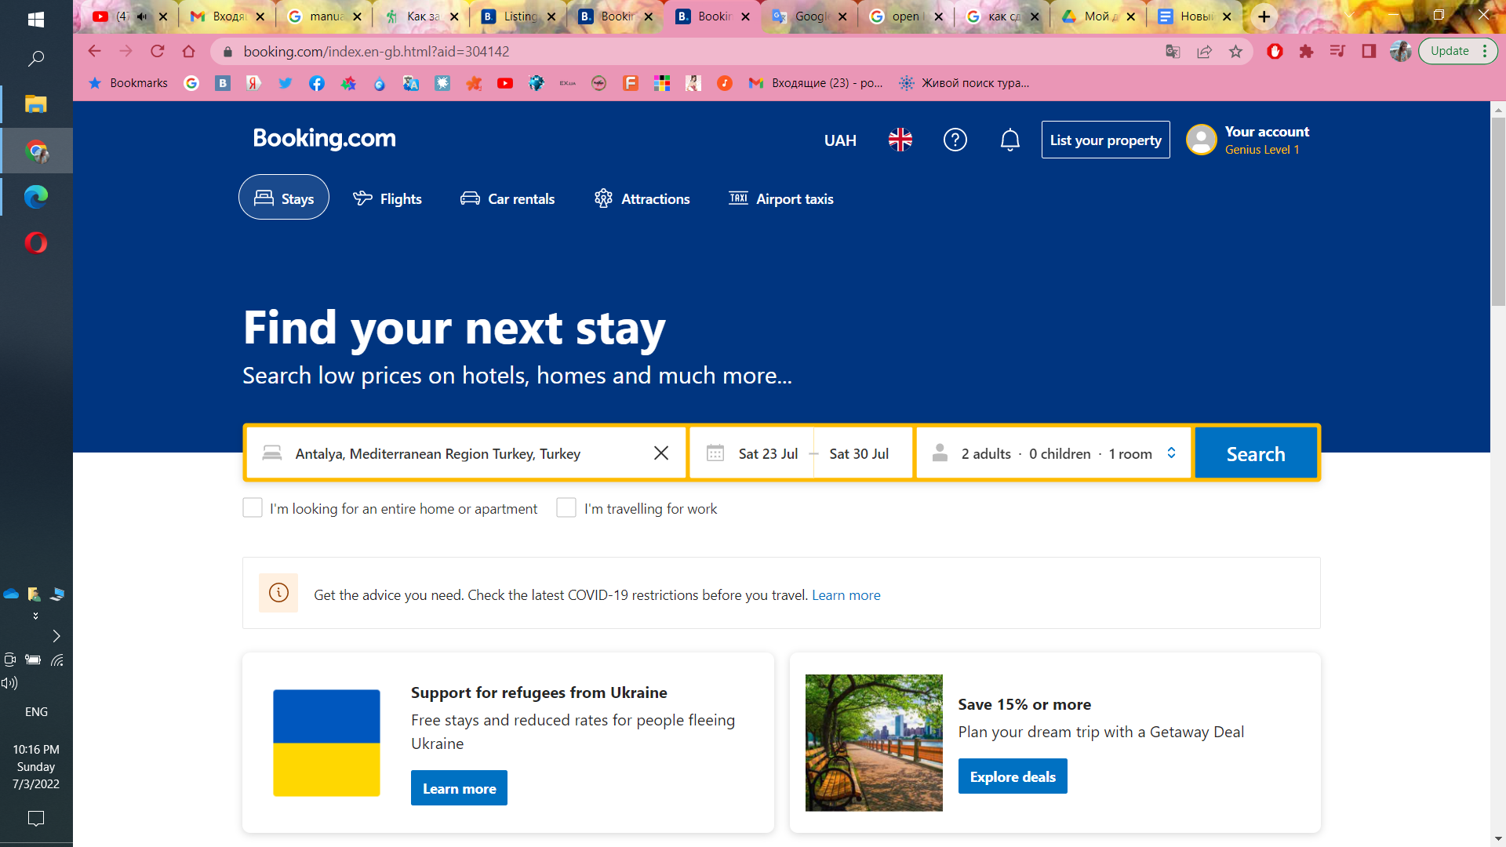

1. Push “Search”. You will see a list of various options, next to which the cost of the reservation for the entire period of your stay at the hotel will be displayed
2. Apply filters on the left side of the page: here you can mark the criteria you are interested in, such as the star rating of the hotel, type of accommodation, attractions, your budget, food, etc
3. At the top, at the beginning of the list with hotels, there is also a filter that sorts options by stars, prices, proximity to the city center, ratings and recommendations of the service

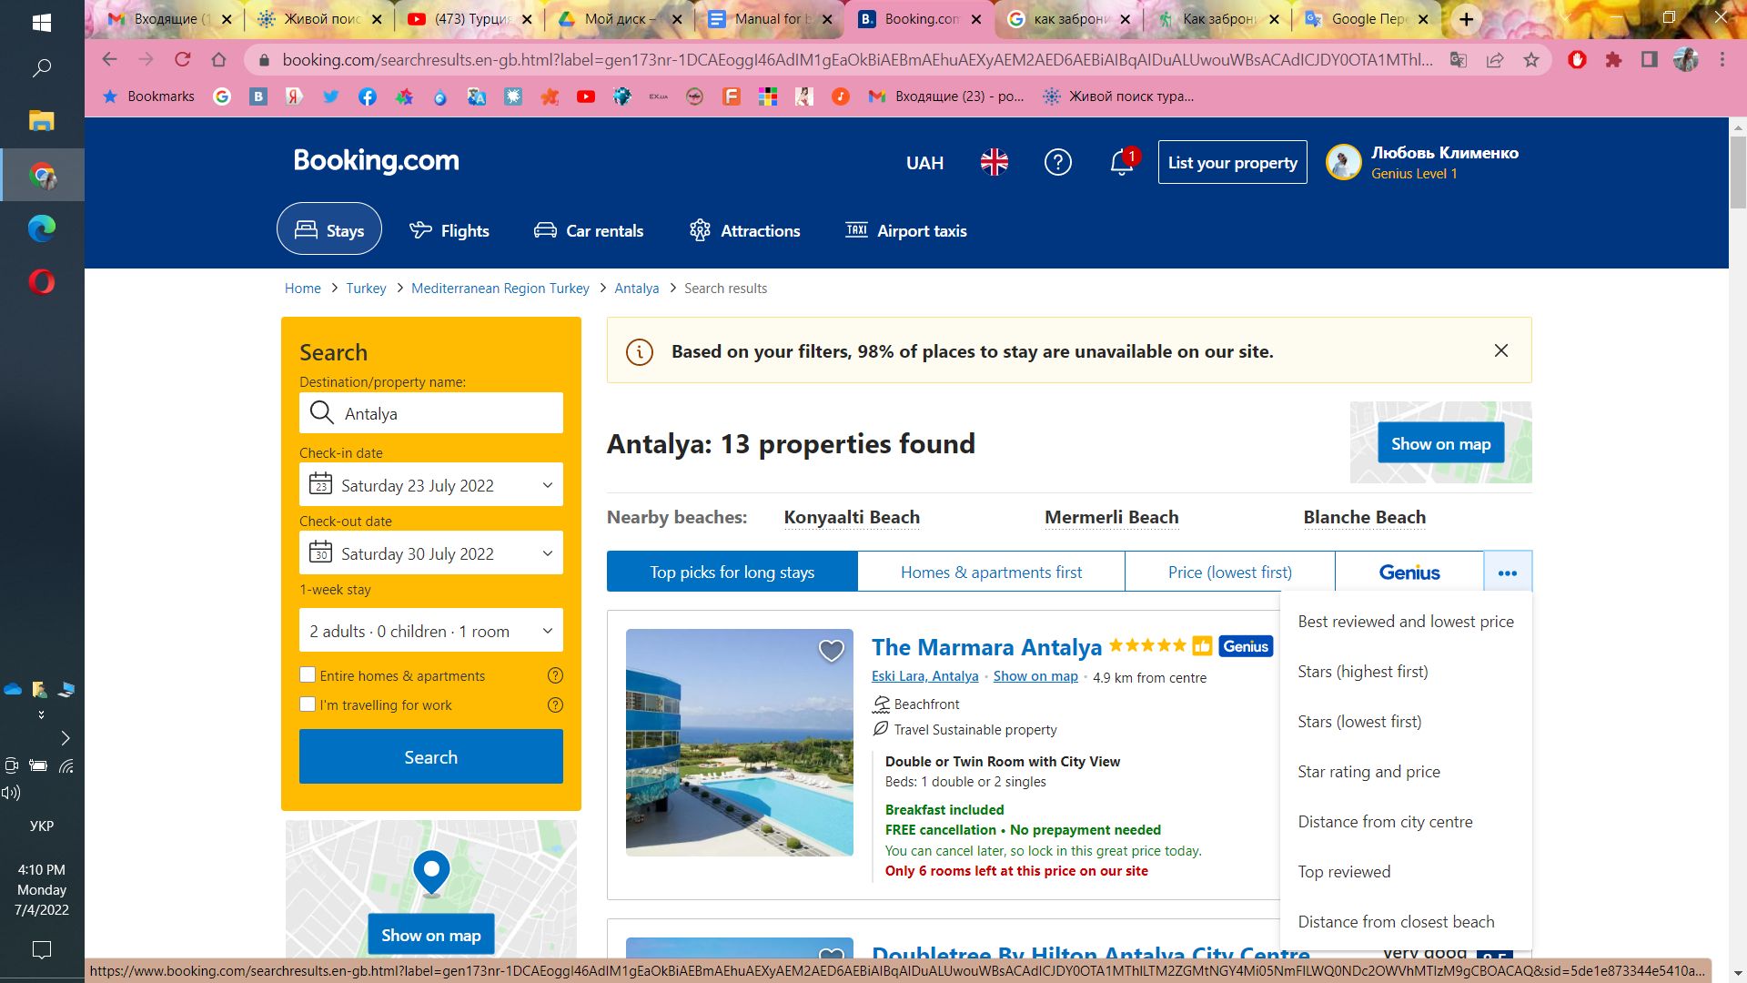

1. For booking click “See availability”
2. On the opening page you will see the parameters of the rooms and how they are equipped, as well as the price of accommodation in different classes of rooms

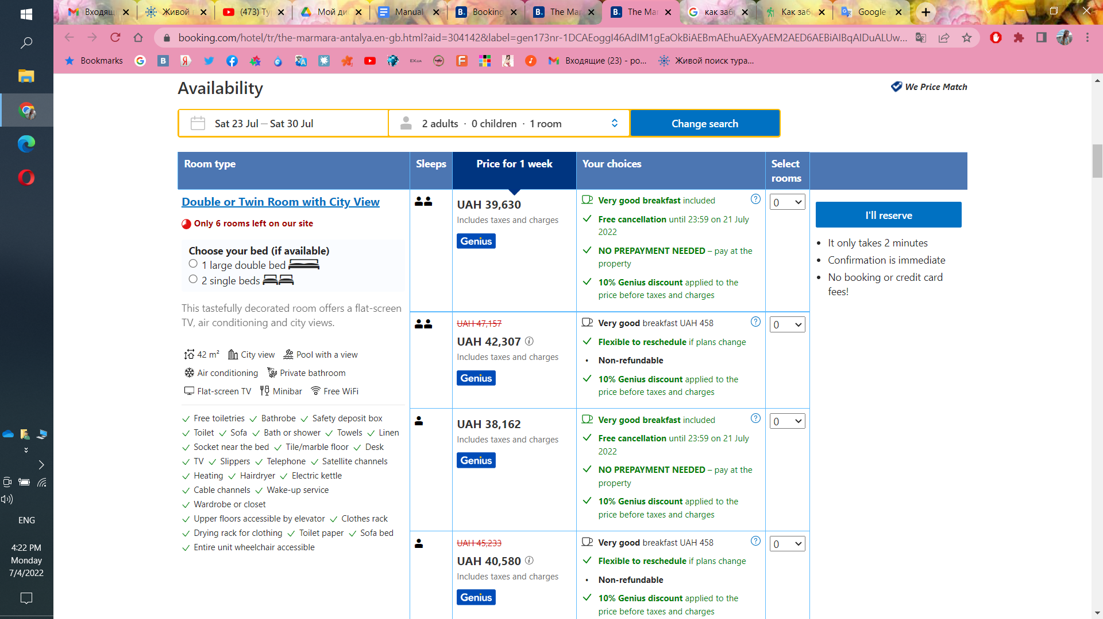

1. Select the number of rooms from the drop-down list and click “Reserve with Genius discount”

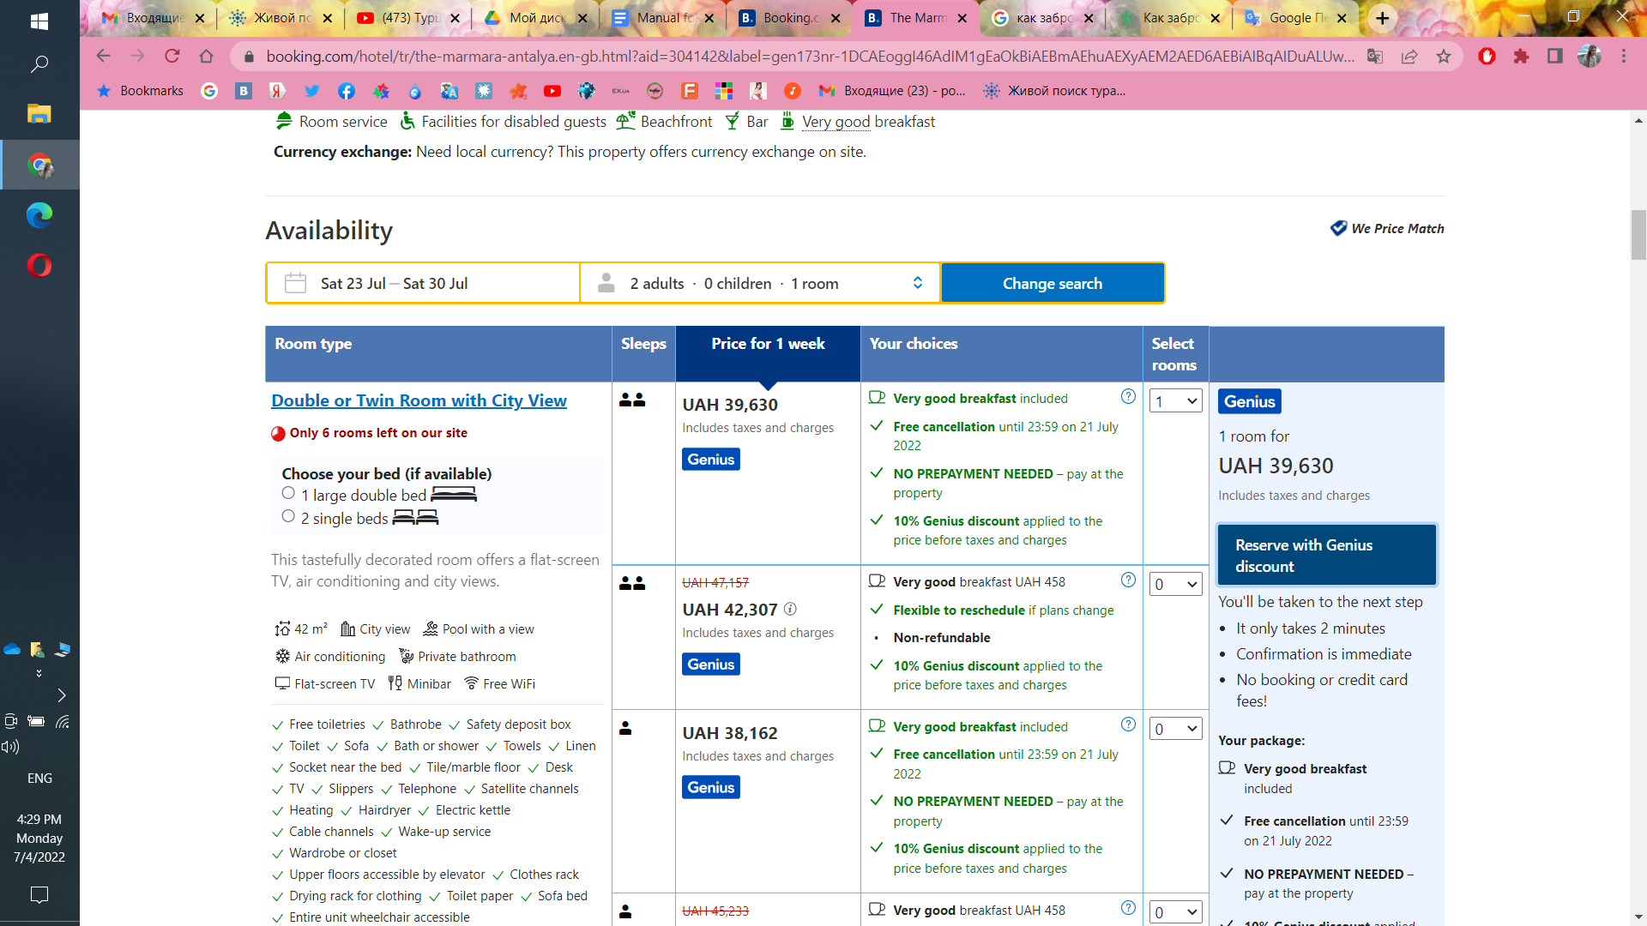

1. In opened window fill personal data

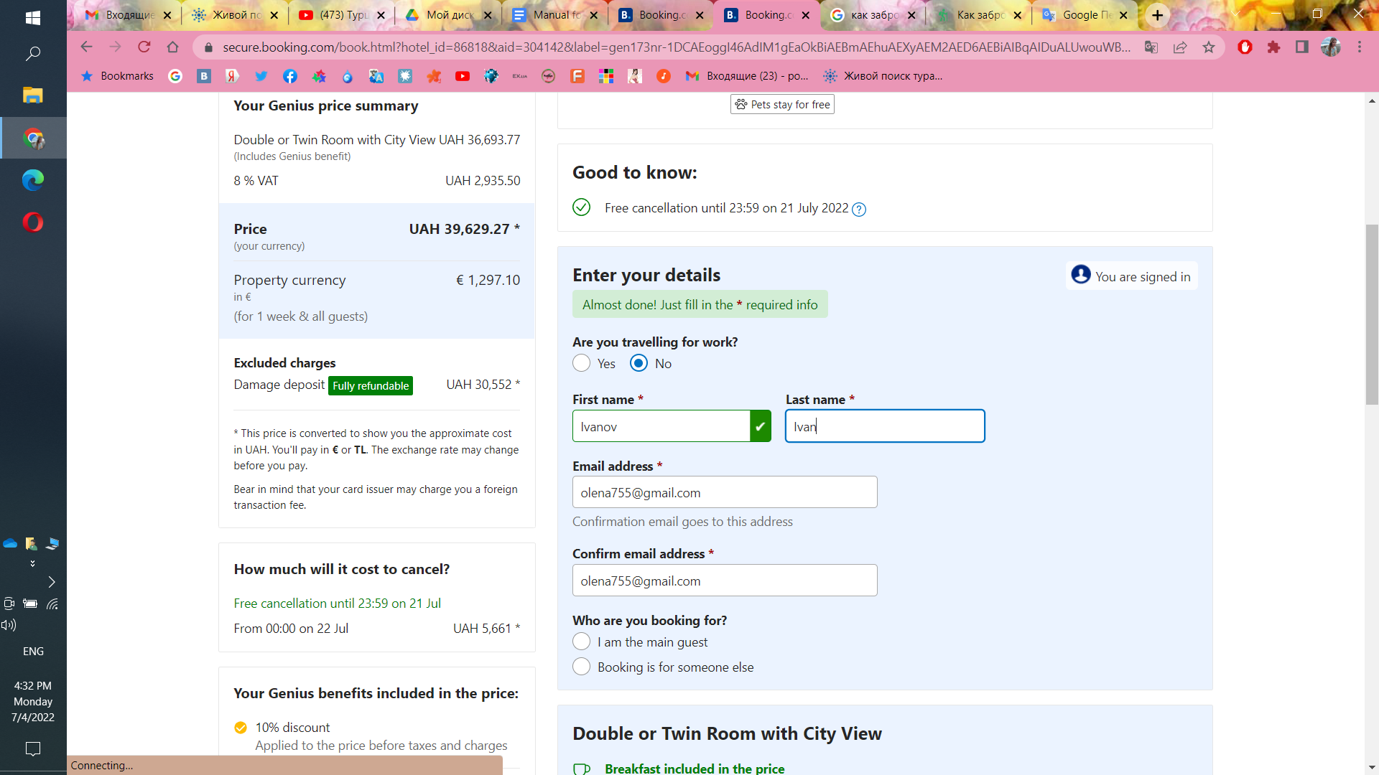

1. Click “Next:Final details”
2. Enter your card details and click “Complete booking”